3GPP TSG-RAN WG3 Meeting #131 R3-260356
Gothenburg, Sweden, 9 – 13 February, 2026

Agenda Item: 9.2.3
Source: Nokia, Deutsche Telekom, InterDigital, BT
Title: Discussion on Exit Conditions
Document for: Decision

1 Introduction
In this paper we provide our views related to the existing exit conditions defined in TS 38.423 and provide some proposed updates. The corresponding CR is in R3-260361.

2 Exit Conditions for UE Performance Feedback
TS 38.423 describes the following exit conditions related to the termination of UE performance measurement collection:
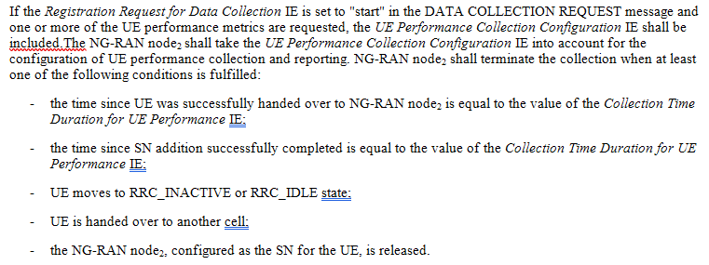
In our view, some corrections are needed, which we discuss next.
UE Performance feedback is reported after a UE is handed over to the target node and is used to evaluate the handover decision. This is done by requesting the target gNB to measure different UE performance metrics (e.g UL/DL Average Throughput, UL/DL Average Delay) per-DRB and aggregate/consolidate them per-UE before reporting them back to the source node. The observed UE Performance will depend on UE configuration including its bearer configuration and radio configuration, and therefore not only on the UE’s radio conditions in the target cell.
Observation 1: UE Performance measurements depend on UE configuration including its bearer configuration and radio configuration.
In addition, in RAN3 #129, it was agreed to introduce Data Collection ID IE in the E1AP BEARER CONTEXT MODIFICATION REQUEST message and allow collection of UE Performance Delay for new bearers to be setup in UE CONTEXT MODIFICATION REQUEST message over F1AP. This was agreed in order to allow a gNB to collect UE performance even for newly added DRB(s). An example where this could be useful is if a source node (before a handover) needs to set up additional bearers and needs to be able to measure UE Performance on those in order to compare the UE Performance before the handover to the UE Performance after the handover event.
Observation 2: Measuring UE Performance Delay for new bearers to be setup is useful in certain scenarios e.g., when a source node establishes new UE bearers for a UE before a handover and needs to measure the overall UE Performance Delay before and after the handover for its evaluation.

However, even though this update in F1AP makes sense for the source node of a handover, if the UE or the Core Network change the bearers for the UE (e.g., in case the UE requests for a new PDU session that can be due to an addition of a service in the UE) the configuration of the UE at the target node will change which would create a situation where the source node can’t compare the reported UE Performance Delay with its own observations when it served the UE. Addition of a new bearer would naturally have impacts to the other UE Performance metrics as well because the source will not be able to determine that the UE bearer configuration at the target has been changed during the data collection due to the introduction of a new PDU session. This will create an issue of incomparability of the reported UE Performance at the source node, given that UE Performance metrics are reported on a per-UE granularity.
Observation 3: If the UE bearer configuration at the target node changes by the UE or the CN due to change in the PDU sessions in the UE, the source node cannot compare the reported UE Performance by the target to the corresponding UE Performance it measured.
We think that this issue needs to be corrected. We identify two options:
- Option 1: New exit condition(s). Similarly to the other exit conditions that we have introduced, the target gNB can monitor if there is any change in the number of bearers due to the introduction of a new PDU session corresponding to a new service while data collection is ongoing and terminate the data collection in that case. This option is simple in that it does not require any special handling at the source node.
- Option 2: Continue to report the data with an indication at the source. Another alternative is that the target continues the data collection after it observes a change in the number of bearers due to a new PDU session, but in that case, it would need to notify the source, otherwise the UE Performance received from the target node cannot be compared to the one that the source measures.

We think that option 1 is a simpler option.

Proposal 1: Introduce option 1 to enable the target node to terminate data collection if the bearer configuration for the UE at the target node after the handover changes due to changes in the PDU sessions for the UE.
Another issue relates to the current way that NR-DC related exit conditions were incorporated in the general data collection termination conditions. In Rel-18 we had agreed that UE Performance terminates when UE is handed over to a subsequent cell, and therefore agreed the following exit condition: “UE is handed over to another cell”. This is due to the fact that for UE Performance we wanted to monitor UE behavior soon after a handover.
However, the same was not agreed for SN Addition. When Dual Connectivity is enabled, the MN needs to determine that the activation of Dual Connectivity is a good decision or a bad decision. Since PSCell selection is at the discretion of the SN it doesn’t matter from MN point of view if SN subsequently chooses different cells to (better) support Dual Connectivity. What matters to the MN is the overall UE Performance under Dual Connectivity. However, we believe there is some risk that the term “handed over” can be interpreted to include PSCell change, and we therefore propose to clarify that only PCell change is in scope of this exit condition.
Proposal 2: Update the exit condition “UE is handed over to another cell” to clarify that only PCell change is within the scope of the exit condition.

3 Conclusion
We make the following observations and proposals:
Observation 1: UE Performance measurements depend on UE configuration including its bearer configuration and radio configuration.
Observation 2: Measuring UE Performance Delay for new bearers to be setup is useful in certain scenarios e.g., when a source node establishes new UE bearers for a UE before a handover and needs to measure the overall UE Performance Delay before and after the handover for its evaluation.
Observation 3: If the UE bearer configuration at the target node changes by the UE or the CN due to change in the PDU sessions in the UE, the source node cannot compare the reported UE Performance by the target to the corresponding UE Performance it measured.
Proposal 1: Introduce option 1 to enable the target node to terminate data collection if the bearer configuration for the UE at the target node after the handover changes due to changes in the PDU sessions for the UE.
Proposal 2: Update the exit condition “UE is handed over to another cell” to clarify that only PCell change is within the scope of the exit condition.

